PROGRAM 6 : Student Academic Risk Classification

1. Problem statement
Develop a Python program that analyzes students' academic performance using their marks, attendance, and laboratory scores. The program should classify students into academic risk categories based on predefined conditions, identify students experiencing more than one risk factor, and display a summary of the results.
2. Objectives
- Store student marks, attendance, and laboratory scores in lists.
- Identify students who fall below academic requirements.
- Classify students into different risk categories.
- Detect multiple simultaneous risk factors.
- Generate a summary showing the number of students in each category.
3. Assumptions and rules
For this example, use the following thresholds:
Factor | Risk condition
Written marks | Below 40 out of 100
Attendance | Below 75%
Laboratory score | Below 40 out of 100
Risk classification:
- High risk: Two or more risk factors.
- Moderate risk: Exactly one risk factor.
- Low risk: No risk factors.
These are sample rules for this assignment, not official college academic regulations.
4. Computational thinking
- Decomposition: Divide the problem into storing data, checking risk factors, classifying students, and preparing a summary.
- Pattern recognition: Identify repeated patterns such as low marks, low attendance, and low laboratory scores.
- Abstraction: Focus on the three important academic indicators and ignore unrelated student information.
- Algorithmic thinking: Check each student's scores against the thresholds and assign a category based on the number of risk factors.
5. Algorithm
- Start the program.
- Store student names, marks, attendance, and laboratory scores in lists.
- Initialize counters for high-, moderate-, and low-risk students.
- Use a loop to examine each student.
- Count the student's risk factors.
- Classify the student based on the number of risk factors.
- Record students with multiple simultaneous risk factors.
- Display each student's results.
- Display the overall risk summary.
- Stop the program.
6 . FLOW CHART
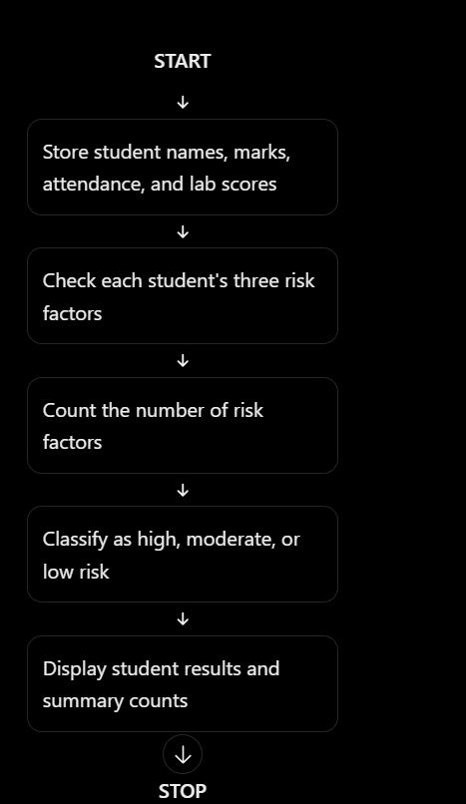

7.PESUDO CODE

START

Store student names, marks, attendance, and lab scores

Set high_risk_count = 0
Set moderate_risk_count = 0
Set low_risk_count = 0

FOR each student
Set risk_count = 0
Set risk_factors = empty list

IF marks < 40
Add "Low Marks" to risk_factors
END IF

IF attendance < 75
Add "Low Attendance" to risk_factors
END IF

IF lab score < 40
Add "Low Lab Score" to risk_factors
END IF

Count risk factors

IF risk_count >= 2
Classify as High Risk
Increase high_risk_count
ELSE IF risk_count == 1
Classify as Moderate Risk
Increase moderate_risk_count
ELSE
Classify as Low Risk
Increase low_risk_count
END IF

Display student classification and risk factors
END FOR

Display category totals
Display students with multiple risk factors

STOP

8.PYTHON SOURCE CODE

# Student Academic Risk Classification

students = ["Asha", "Ravi", "Priya", "Kiran", "Meena", "Arjun"]

marks = [35, 65, 45, 30, 80, 38]
attendance = [68, 82, 70, 60, 90, 80]
lab_scores = [32, 55, 35, 28, 75, 60]

high_risk_count = 0
moderate_risk_count = 0
low_risk_count = 0

multiple_risk_students = []

print("===== STUDENT ACADEMIC RISK REPORT =====")

# Examine each student
for i in range(len(students)):
risk_factors = []

# Check written marks
if marks[i] < 40:
risk_factors.append("Low Marks")

# Check attendance
if attendance[i] < 75:
risk_factors.append("Low Attendance")

# Check laboratory score
if lab_scores[i] < 40:
risk_factors.append("Low Lab Score")

risk_count = len(risk_factors)

# Classify academic risk
if risk_count >= 2:
category = "High Risk"
high_risk_count += 1
multiple_risk_students.append(students[i])

elif risk_count == 1:
category = "Moderate Risk"
moderate_risk_count += 1

else:
category = "Low Risk"
low_risk_count += 1

# Display individual student report
print("\nStudent:", students[i])
print("Marks:", marks[i])
print("Attendance:", attendance[i], "%")
print("Lab Score:", lab_scores[i])
print("Risk Factors:", risk_count)

if risk_factors:
print("Details:", ", ".join(risk_factors))
else:
print("Details: No risk factors")

print("Category:", category)

# Display overall summary
print("\n===== SUMMARY =====")
print("Total students:", len(students))
print("High Risk:", high_risk_count)
print("Moderate Risk:", moderate_risk_count)
print("Low Risk:", low_risk_count)

print("\nStudents with multiple risk factors:")
if multiple_risk_students:
for student in multiple_risk_students:
print(student)
else:
print("None")

print("\nAnalysis completed.")

9. Test cases
Test case | Marks | Attendance | Lab score | Expected category
1 | 35 | 68% | 32 | High Risk
2 | 65 | 82% | 55 | Low Risk
3 | 45 | 70% | 35 | High Risk
4 | 38 | 80% | 60 | Moderate Risk
5 | 80 | 90% | 75 | Low Risk
10. Expected output
===== STUDENT ACADEMIC RISK REPORT =====

Student: Asha
Marks: 35
Attendance: 68 %
Lab Score: 32
Risk Factors: 3
Details: Low Marks, Low Attendance, Low Lab Score
Category: High Risk

Student: Ravi
Marks: 65
Attendance: 82 %
Lab Score: 55
Risk Factors: 0
Details: No risk factors
Category: Low Risk

Student: Priya
Marks: 45
Attendance: 70 %
Lab Score: 35
Risk Factors: 2
Details: Low Attendance, Low Lab Score
Category: High Risk

Student: Kiran
Marks: 30
Attendance: 60 %
Lab Score: 28
Risk Factors: 3
Details: Low Marks, Low Attendance, Low Lab Score
Category: High Risk

Student: Meena
Marks: 80
Attendance: 90 %
Lab Score: 75
Risk Factors: 0
Details: No risk factors
Category: Low Risk

Student: Arjun
Marks: 38
Attendance: 80 %
Lab Score: 60
Risk Factors: 1
Details: Low Marks
Category: Moderate Risk

===== SUMMARY =====
Total students: 6
High Risk: 3
Moderate Risk: 1
Low Risk: 2

Students with multiple risk factors:
Asha
Priya
Kiran

Analysis completed.

11. Conclusion
The program analyzes student marks, attendance, and laboratory scores using Python lists and conditional statements. It identifies multiple risk factors, classifies students into three academic risk categories, and generates a summary that can help teachers identify students who may benefit from additional academic support.

